Title（Verdana 16pt bold）
―Subtitle（Verdana 14pt bold）―
(empty line)
Kisoken Taro（Verdana 12pt bold）
Graduate Student, Kisoken University（Verdana 12pt bold）
(empty line)
This is the template for the Reports of 2020 FFLER SIG.
（Write the most important point of the article in 50 words）

Abstract
Start writing abstract from here. Abstract must be no longer 250 words. Choose three keywords that are most relevant to the paper.
(empty line)
Keywords: L2 Speaking, Task Complexity, Attention Orientation
（empty line）
(empty line)
(empty line)
1. Major Headings
Section headings are Verdana, font size 10.5 points, and boldface. They are justified to the left edge with the first word capitalized and the rest of the heading in lower case.
(empty line)
1.1 Sub headings
Sub-headings appear like major headings, except the first letter of the first word is capitalized and all the other words are not capitalized.
(empty line)
1.1.1 Sub-sub headings
Sub-sub-headings appear like sub-headings, except they are in italics. No more than 3 levels of headings should be used.
(empty line)
（Go to the next page）
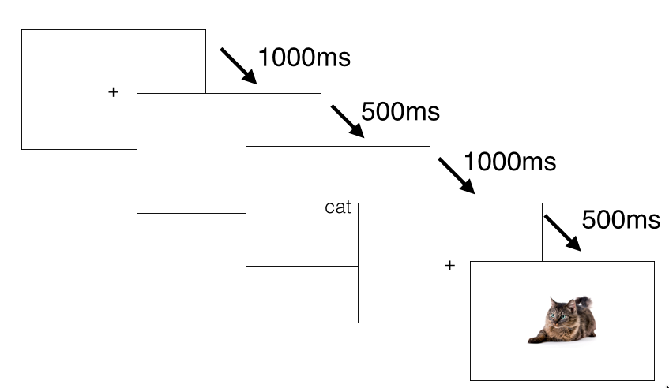
Figure 1
This is an example of a figure.
(empty line)
Table 1
This is an Example of a Table
 | n | M | SD | 95% CI
Variable 1 | 200 | 50.13 | 10.12 | [47.21, 51.34]
Variable 2 | 200 | 50.32 | 10.21 | [47.91, 51.34]
Variable 3 | 203 | 50.21 | 10.31 | [47.31, 52.51]
Variable 4 | 202 | 50.21 | 10.45 | [46.21, 54.35]
Note. The font should be Arial
(empty line)
（If sections begin right after tables or figures, add another empty line）
2. Reference
The reference format should follow APA and the template of Language Education & Technology.¹

Note
- Do not use footnotes. Use endnotes.

Acknowledgements
Do not write acknowledgements to the SIG members and the editorial committee members.

References
Lacouture, Y., & Cousineau, D. (2008). How to use MATLAB to fit the ex-Gaussian and other probability functions to a distribution of response times. Tutorials in Quantitative Methods for Psychology, 4, 35–45. Retrieved from http://www.tqmp.org/Content/vol04-1/p035/p035.pdf
Jiang, N. (2012). Conducting reaction time research in second language studies. Routledge.
Miller, K., Lindgren, E., & Sullivan, K. (2008). The psycholinguistic dimension in second language writing: Opportunities for research and pedagogy using computer keystroke logging. TESOL Quarterly, 42, 433–454. https://doi.org/10.1002/j.1545-7249.2008.tb00140.x

Author Information

Taro KISOKEN：Graduate Student, Kisoken University. He is a part-time lecturer at Kisoken Women’s College. His research interests are foreign language teaching, reading in a foreign language, and vocabulary instruction. He is a student member of the Japan Association for Language Education and Technology (Write your information following this sample).
Optional: Insert your photo (black and white) here.

Appendix
We strongly recommend that the authors include raw data or materials used in the study as Appendix. However, care should be taken to ensure the confidentiality and to follow a code of research ethics.

